Construction System Website Documentation

* Why a website?

Firstly, we developed a C# program, but it’s exclusively for Windows machines. This means that if someone wants to open it in a MAC it won’t work. So, Daniel did a very simple webpage that had four commands to control the motors. This worked better.

In conclusion, with John’s help, we decided an official website would be a better idea. Users just need to open their browsers, look for the website and that’s it, construction system ready to build!

* 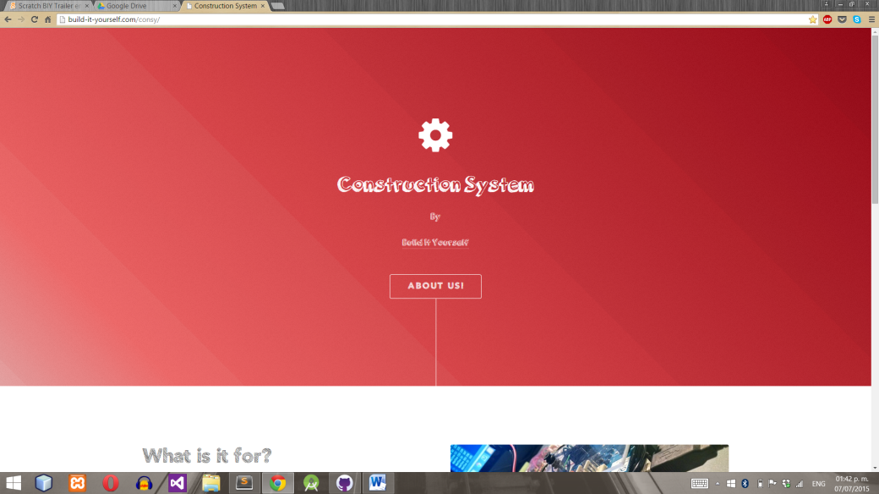Website structure

Splash screen

When the user opens the page, this screen will appear and do some cool effects.

Information

What is it for? Just some points to explain why BIY is developing it.

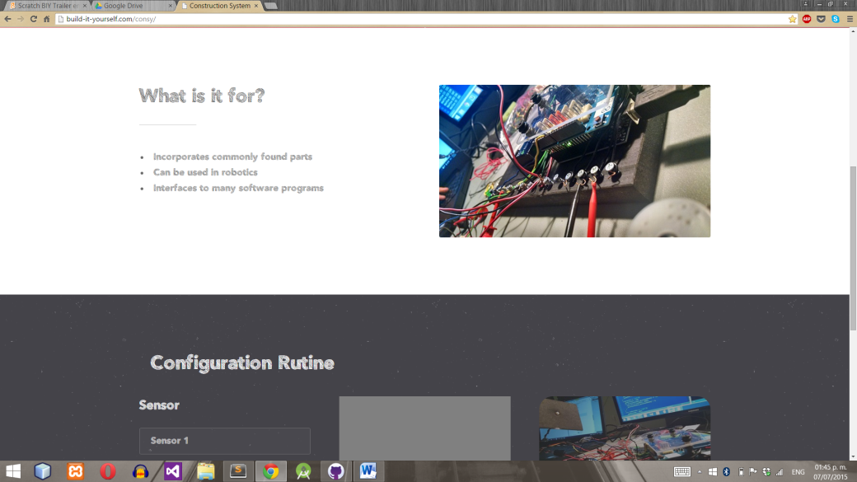

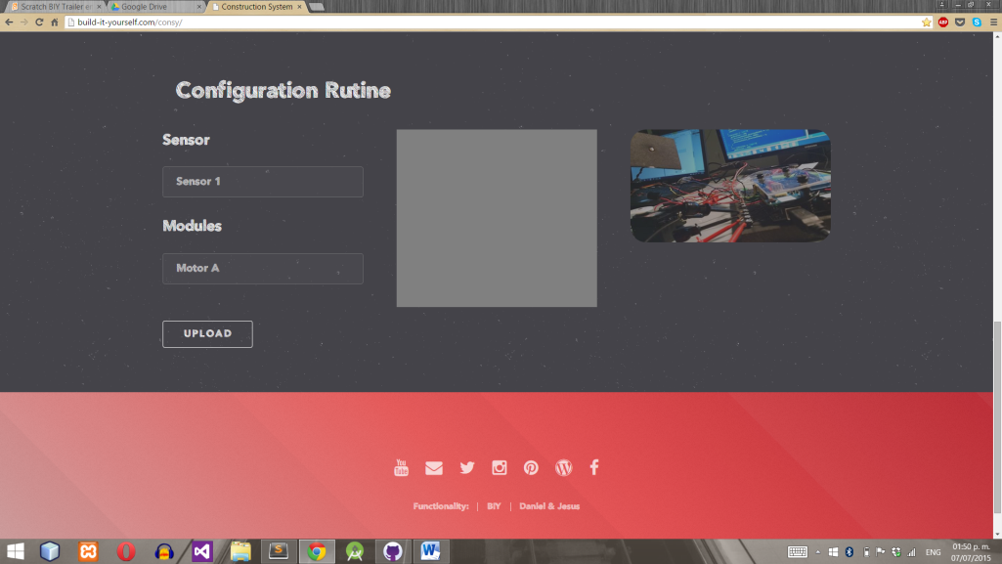Setup area

Right here, the user can select which sensor he/she wants to us (Sensor 1 or Sensor 2) and which module (Module A, Module B and Servo).

When Upload is clicked, the square color is going to change many times.

* When Upload clicked…

To program its function, we used jQuery. You can find it in the same area where all JavaScript code was written.